Course Compendium

C

S

C



Half Day Advanced Practice Courses

- abcdEFMSM : Advanced Update (CME approval)

One Day Courses

- abcdEFMSM: Annual Advanced EFM (NICHD Guidelines)

- Critical Concepts in Perinatal Nursing:
Antepartum-Intrapartum-Postpartum

- Perinatal Emergencies & Strategies

- OB Trauma & Safety: Outrageous Case Studies from the Field

- Perinatal Survival Island: Who Stays? Who Goes? –
Advanced Principles in OB Physical Assessment

- L&D to ICU: Critical Care Strategies & Challenges
(BCLS, ACLS, & Perimorteum C-Section)

- Medical-Legal Challenges in Perinatal Care

- OB Emergencies: Skills & Drills

- Perinatal Quality + Safety + Risk Reduction Strategies

One or Two Day Courses

*abcdEFMSM: Critical Core Concepts (NICHD Guidelines)

*abcdEFMSM: Advanced 2D Course (NICHD Guidelines)

*abcdEFMSM: The MASTER Course in EFM

- CODE BLUE FHR L&D: Evidenced-Based Practice for
Fetal Sentinel Events
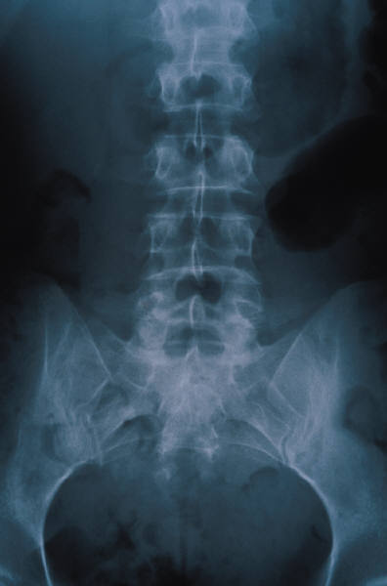
- Labor to Birth: High Risk Intrapartum Labor Management

- “Mentor Me”: Preceptor Guidance & Orientation Process

- Charge Nurse Survival Guide: Wisdom & Guidance in being a
Nurse Leader

- OB Legal: A Mock Trial

Multi-Day Courses (Orientation Process of New Employees)
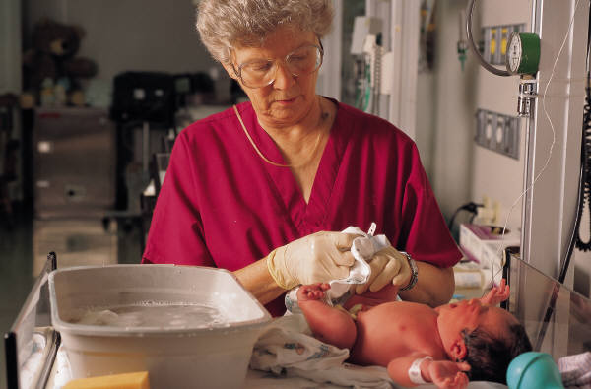
- NEW: Critical Care Obstetrics & Transport (3 Day Course)

- OB Core: Low Risk (1 week or 2 week option/10-14days)

- OB Core: High Risk (1 week/3-6days)

Clinical Specialists Consulting, Inc
745 Kingston Drive * Virginia Beach, VA * 23452 * Phone &Fax: (757) 631-8837
* www.cscwebsite.com & www.abcdefm.com

